#### ICTTEN622 Assessment Tasks

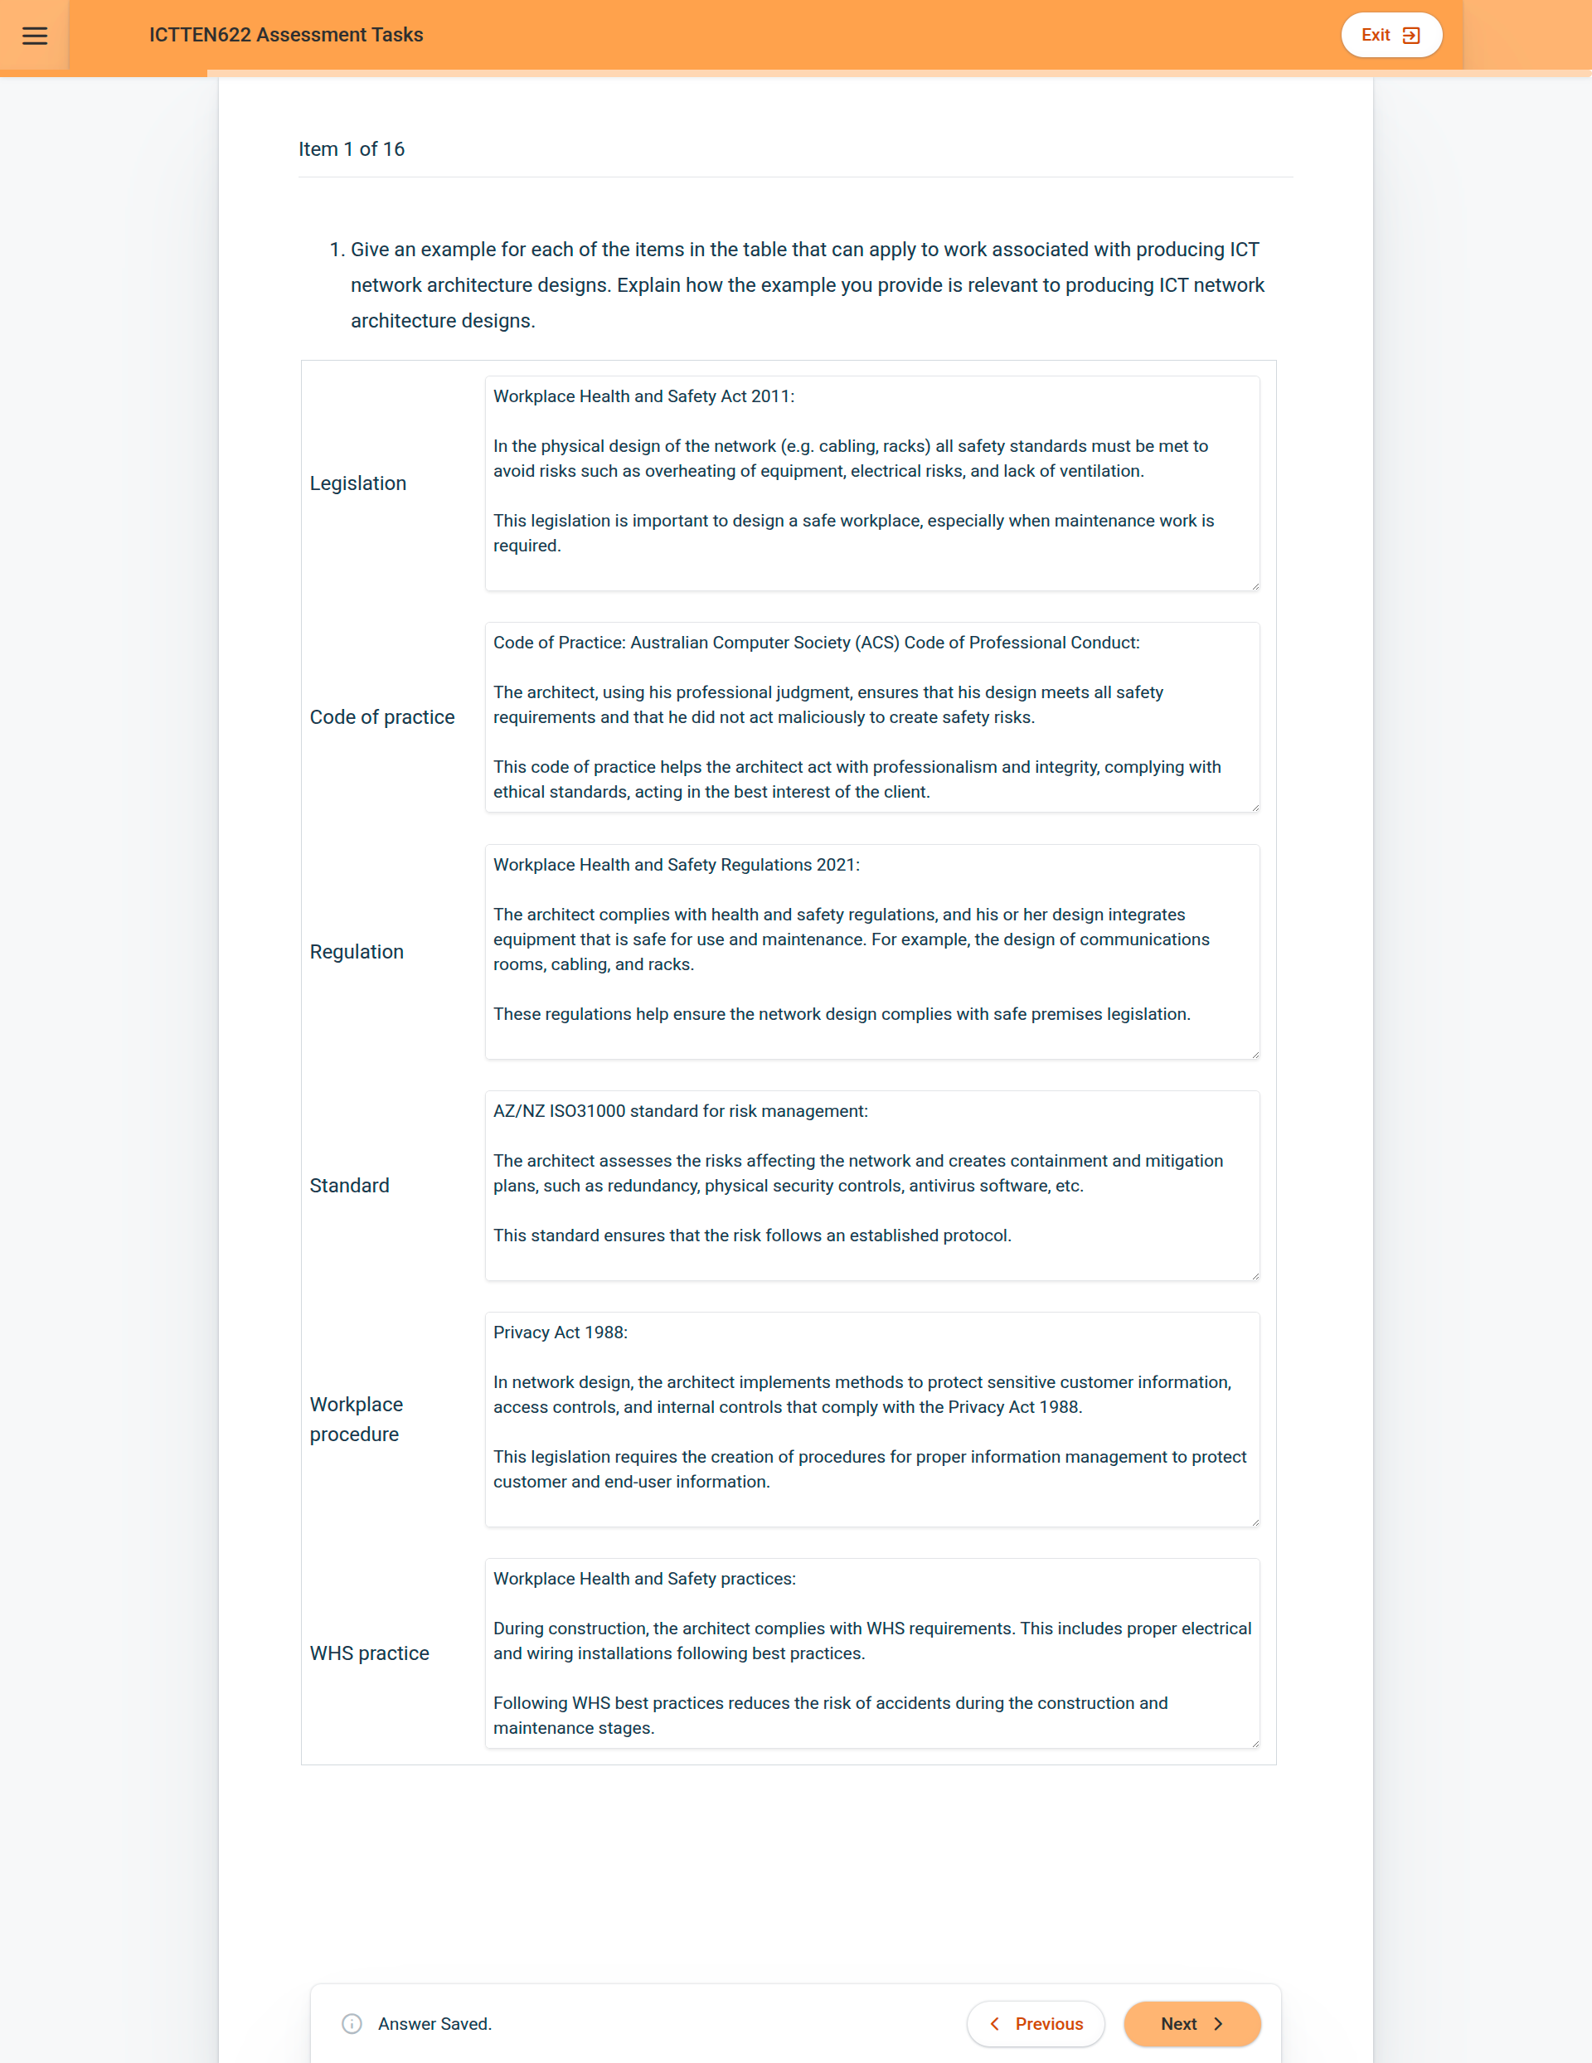

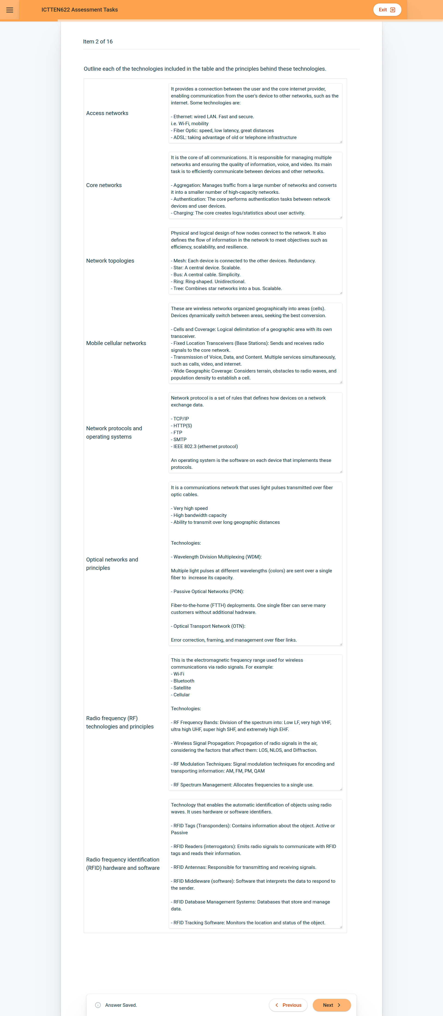

aaaaaaaaaaa